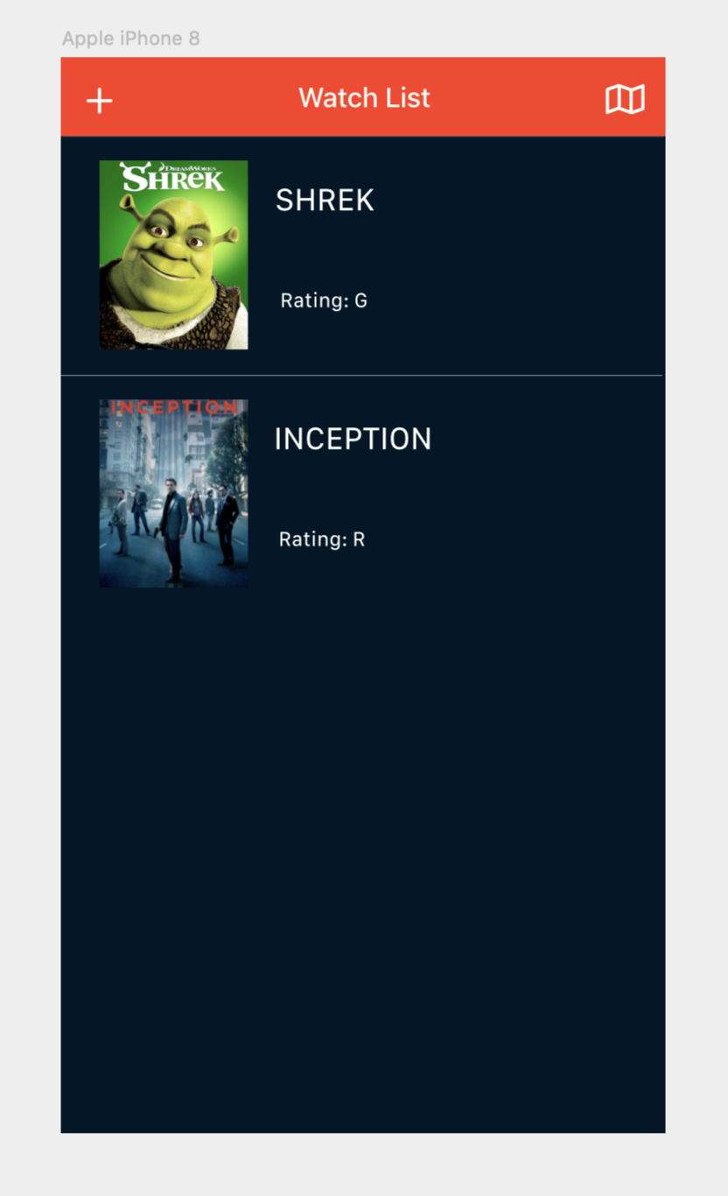

This is the main view controller which is the welcome page for the app. This page shows the movies that are on the users watch list and from here, the user can choose to go to the map in order to see your location and the location of nearby movie theaters on the map. Another page you can go to is the detailed view for each movie which gives you information about each movie.

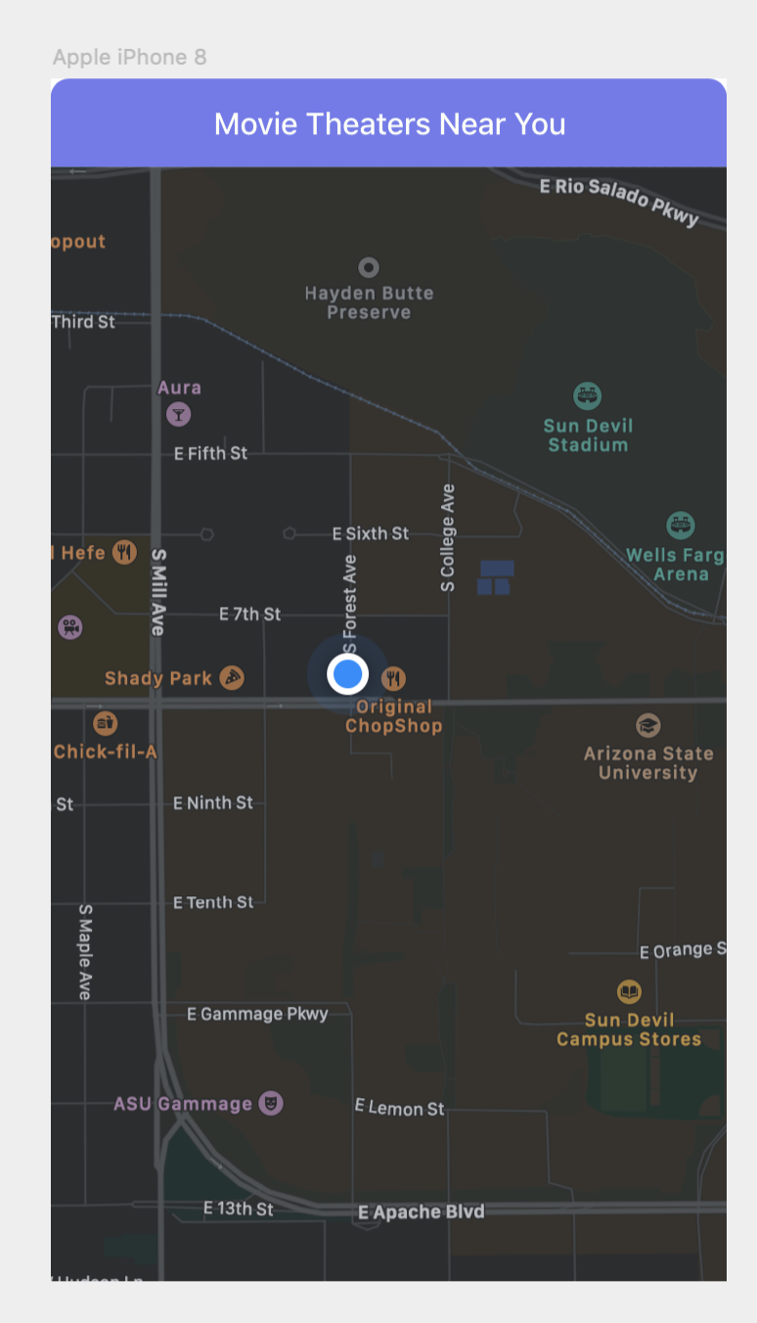

This screen gives you the location of you on the map and the location of the nearest movie theaters

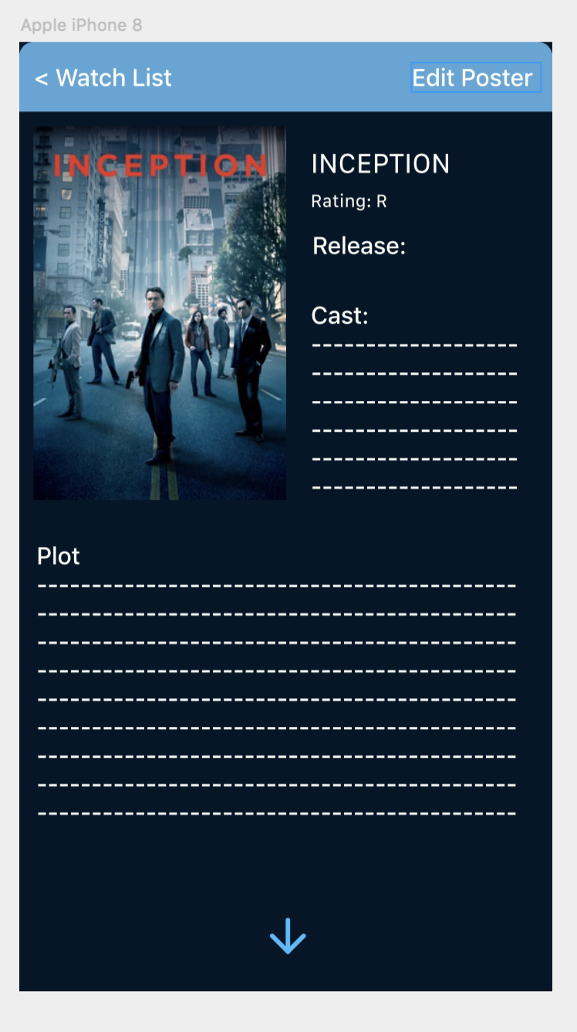

This Screen gives you the data for each of the movies. Some of that data is The Rating of the movie and the plot of the movie. Scrolling down gives you the rating of the movie. The movie poster is fetched from the API and the user has the ability to modify the movie poster by inserting their own image or taking their own image.

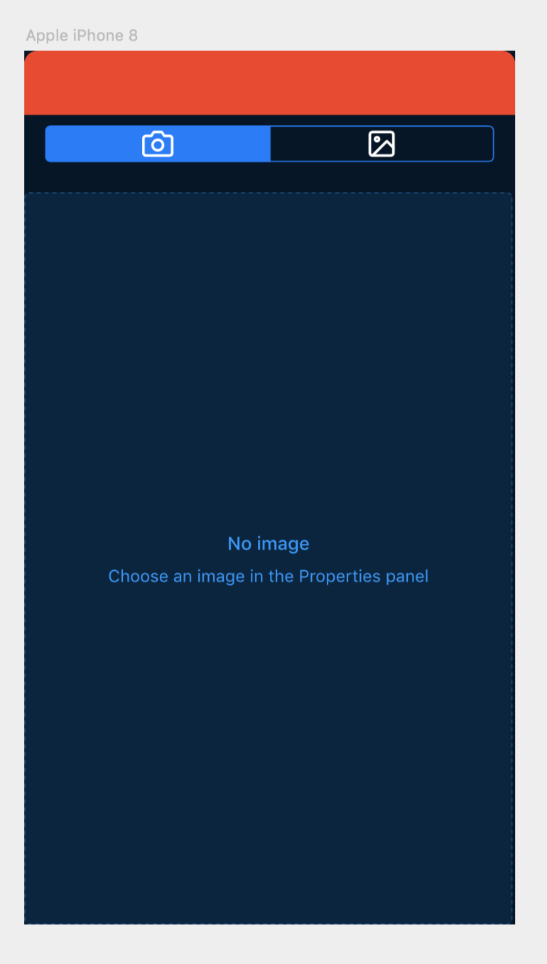

This screen allows the user to toggle between using the photos from their camera and their photo library.

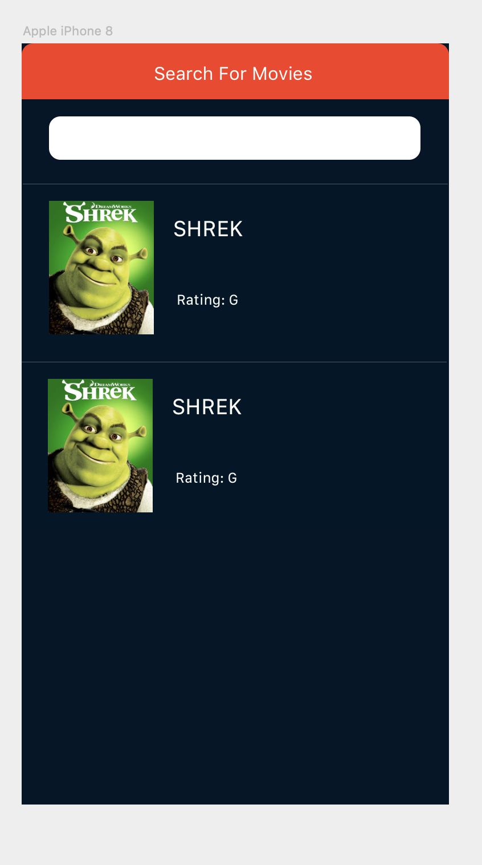

This view allows the use to search for the movies in the database and select the one that they are trying to look for